Architecture Design Document

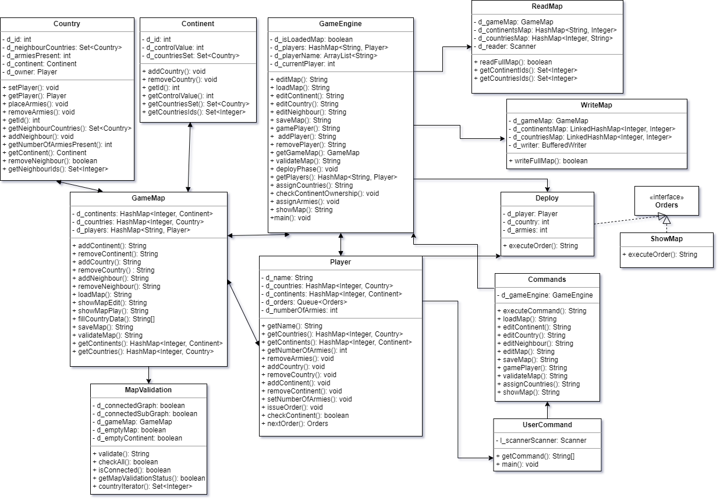

*Description:*

**Class Commands**

This class will execute all commands by user which are fetched from UserCommand Class.

**Class UserCommand**

This class will get user commands and call execute in Commands Class.

**Class GameEngine**

This class handles most part of the game. It is controller of the game and all the operations will execute from this class.

**Class Country**

This class contain all details of country like ID, Continent, Neighbours, Owner, No. of Armies etc.

**Class Continent**

This class contain all details of country like IDs of Country , Control Value.

**Class Player**

This class contain all details of country like name of player, ID, dominated Countries and Continents, No. of Armies, Orders etc.

**Class GameMap**

This class will handle all the operations related to map like add/remove Countries and/or Continents, add/remove neighbours, load map, save map, validate map, show map.

**Class WriteMap**

This class will write game map as text in map file.

**Class ReadMap**

This class will read data from map file.

**Class MapValidation**

This class will validate map which is created by user, according to rules of the game.

**Class Deploy**

This class will deploy armies according to orders issued by the player.

**Class ShowMap**

This class will execute show map command at any time in the game.

**Interface Orders**

This interface provide structure for execute order.